Thursday, 10 September 2026, postcard

London to Paris, Hotel le Grand, Rachel

Our prearranged limo to the train station wanted to pick us up at 8:15 am and asked that we be "in the hotel lobby" 10 to 15 minutes early. We called them the day before, in case they didn't realize that the car couldn't come to the hotel door (they didn't), and arranged to meet at the intersection where our taxi from the airport had dropped us off, a few yards north.

The driver was prompt, and despite maddening traffic, got us to St. Pancras station in good time. Pret A Manger was right there, next to the waiting area, to supply breakfast, but I was too busy juggling luggage, pastries, and hot chocolate to take any photos.

The waiting area, even in Eurostar Premier, was chock-a-block, so we had to sit separately, unable to find two seats together. But when the train ahead of ours, which was delayed a half hour, finally boarded, things thinned out. Ours boarded on time, and we were off through the Chunnel.

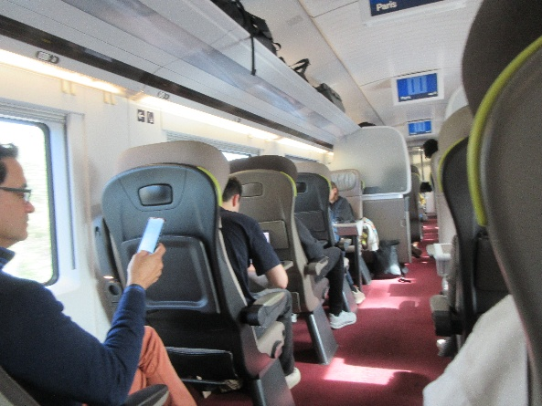
The seating in the train was quite comfortable. In "premier" it was three-across: one on one side and two on the other.

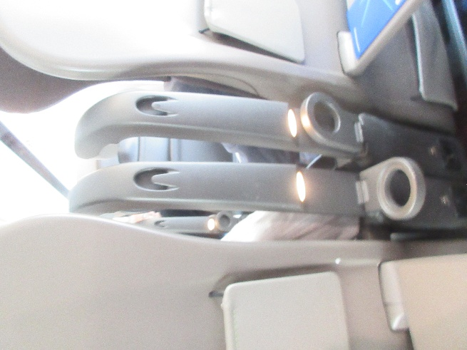
Between the seats n front of us were these graceful paired stanchions, each holding a fold-down cup holder and a coat hook. Additional coat hooks hung from rails above the windows. You can see a couple of pairs of them in the left-hand photo (where you can see a little rectangle set into the top of each seatback; that was a fold-out make-up mirror!). Each seatback had a sturdy fold-down table and a couple of elasticized pouches. The top ends of the stanchions were reading lights for the row in front.

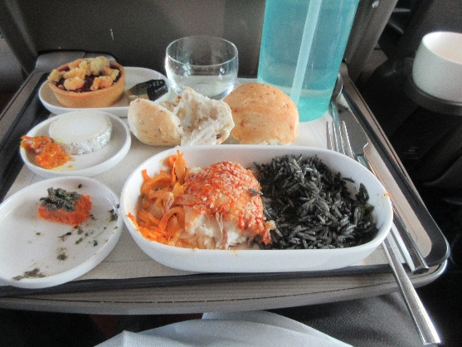
On our last Eurostar ride, we bought sandwiches in the station to eat on the train, not knowing that we would be served lunch. Good thing, too, as the tabouleh we were served was so awful that we ate the sandwiches instead. This time, one step up in class and forewarned that lunch was included, we skipped the sandwiches, and the lunch turned out to be quite good.

Here's my baked hake coated with sesame seeds, ginger-flavored squid-ink rice, and hot and sour fennel. To the left of it is a square of a sort of red pepper frittata topped with braised zucchini, a slice off a log of outstanding chevre cheese with a dab of (I think) apricot mostarda, and a dessert that was described on the menu as a brownie of some sort but turned out to be a blueberry-raspberry crumble tart. David got all the same side dishes, but his grilled chicken turned out to be a cold chicken salad with a couple of cold vegetable salads.

Two hours and eight minutes (plus a one-hour time-zone change), we arrived at the Gare du Nord in Paris, where the driver of the limo from Tauck was waiting for us right where she was supposed to be. She escorted us to a vehicle very much like the one that picked us up in London, a Mercedes with six seats in the back, arranged to face each other in rows of three, a seventh seat next to the driver, and room in the wayback for luggage. Each of our seats was provided with two chilled half liters of water, and facing us was a basket of candy: the famous nougat from Montelimar, a tin of something from Provence, and a box of After Eight mints. We did not partake.

Traffic was horrible, but she navigated us skillfully to the hotel Intercontental Le Grand, just a block from the classic Garnier Opera House. One or our rooms was ready, so we were able to park our luggage, but the second room wasn't ready until 5 pm! In the meantime, we checked in with Tauck, got our information packets, lists of other guests, excursion questionnaires, etc. Rachel was already there, having a cup of tea in the bar, so I went and chatted with her while David napped. Once we were all finally installed in our rooms and freshened up, we met in the hotel's Café de la Paix (yes, the Café de la Paix) for introductions, briefings, and dinner.

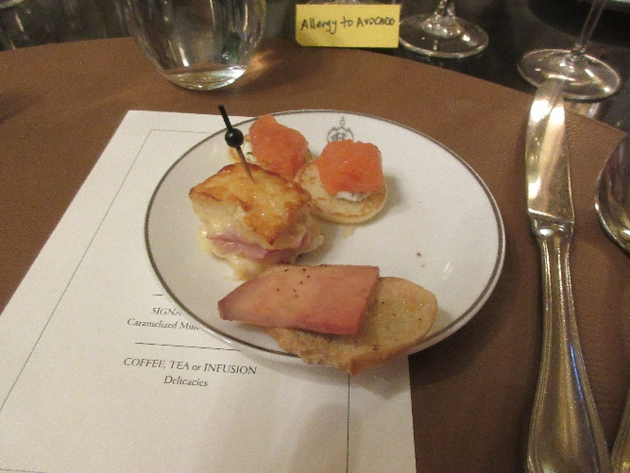
I didn't do a very good job of photographing the food, but here are the amuse bouches: a tiny smoked salmon blini, a piece of toast with a slice of cold foie gras, and a little square cut from a croque-monsieur (French-style grilled cheese sandwich). Rachel gave me her blini, since she's allergic to fish. Note the little yellow allergen sign behind my plate, warning the waitstaff that I'm allergic to avocado. Rachel had one, too, but the waitstaff didn't pay much attention to it.
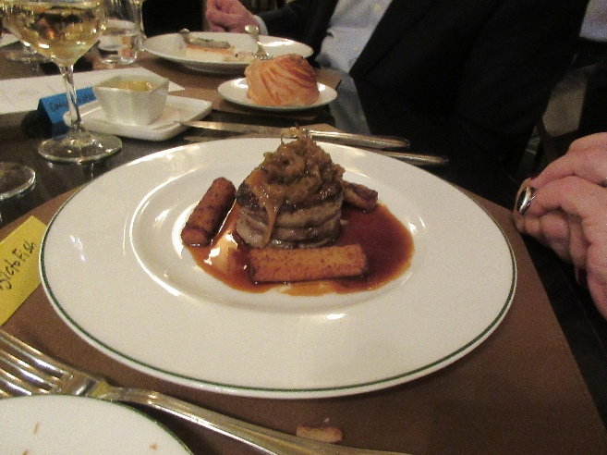
The second course was excellent mushroom soup with cockles in it, which I didn't photograph. The main was grilled filet of daurade royale (gilt-head seabream) with an interesting slice of slightly sweet sticky shortgrain rice that had been grilled on top. They brought the same to Rachel, who had to point out the "allergic to fish" sign by her plate, at which point they brought her this magnificent filet mignon. The crispy cylinders are coarsely puréed vegetable that we couldn't identify: parsnips?, potatoes?, turnip?, some combination of those?
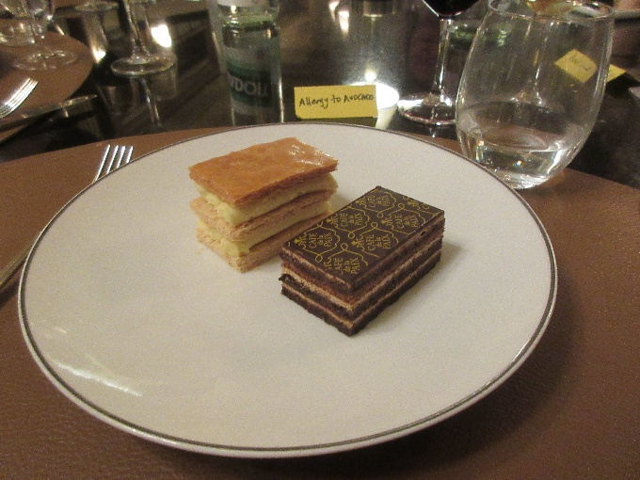
Dessert was a slice of chocolate "opera" cake and a small vanilla millefeuille (Napoleon). They wouldn't serve to Rachel on the grounds that it might contain hazelnuts (her other allergy). They offered fruit salad, but she requested vanilla ice cream instead.

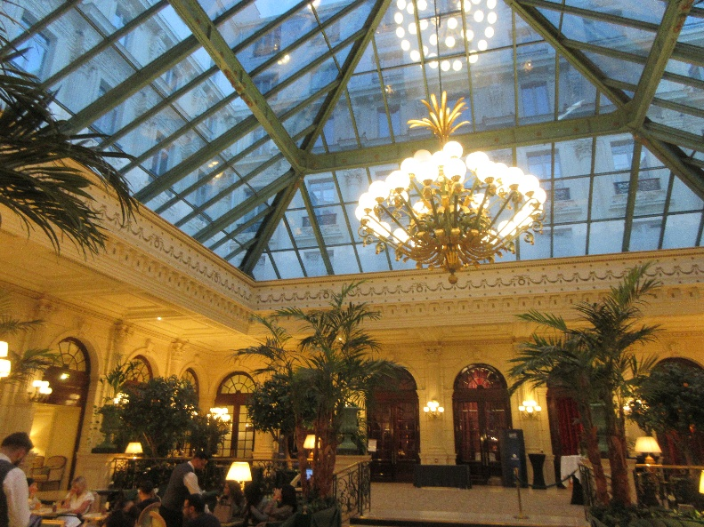
The hotel is triangular, and the open center is occupied by the "Verrière," this glass-domed atrium.

